Music Performance & Streaming Analytics Using MS Excel and Power BI

1. Project Overview
The music industry generates massive amounts of streaming data across digital platforms such as Spotify, YouTube, TikTok, Apple Music, Pandora, Deezer, Amazon Music, and SoundCloud. This project transforms raw music streaming data into meaningful business insights through data cleaning, exploratory data analysis (EDA), and interactive dashboard development using Microsoft Excel and Power BI.

2. Project Objectives
• Clean and standardize the raw music dataset.
• Handle missing values and duplicate records.
• Validate track, album, and artist metadata using ISRC where possible.
• Analyze artist performance, song performance, platform engagement, trends, and relationships.
• Build an interactive Power BI dashboard.
• Generate business insights and recommendations.

3. Data Source
Dataset: Most Streamed Songs 2024 Dataset
Domain: Music Streaming Analytics
Dataset Size: Approximately 4,600 songs (final cleaned dataset: 4,598 songs), 27 columns.
Platforms: Spotify, YouTube, TikTok, Apple Music, Deezer, Pandora, Amazon Music, SoundCloud, and Shazam.

4. Problem Statement
The music industry releases thousands of songs across multiple streaming services. This project identifies top-performing artists, songs, albums, platform contributions, release trends, and relationships between streaming metrics to support data-driven decision-making.

5. Dataset Understanding
Key fields include:
• Track Name
• Album Name
• Artist Name
• ISRC
• Release Date
• All Time Rank
• Track Score
• Spotify Streams, Playlist Count, Playlist Reach, Popularity
• YouTube Views, Likes, Playlist Reach
• TikTok Posts, Likes, Views
• Apple Music Playlist Count
• Deezer Playlist Count & Reach
• Pandora Streams & Track Stations
• SoundCloud Streams
• Shazam Counts

6. Data Cleaning & Pre-processing
• Removed duplicate records.
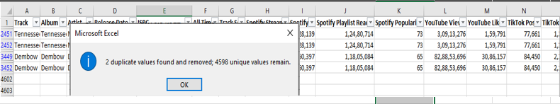
• Handled missing values.
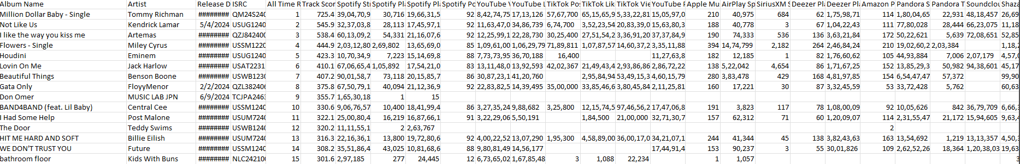
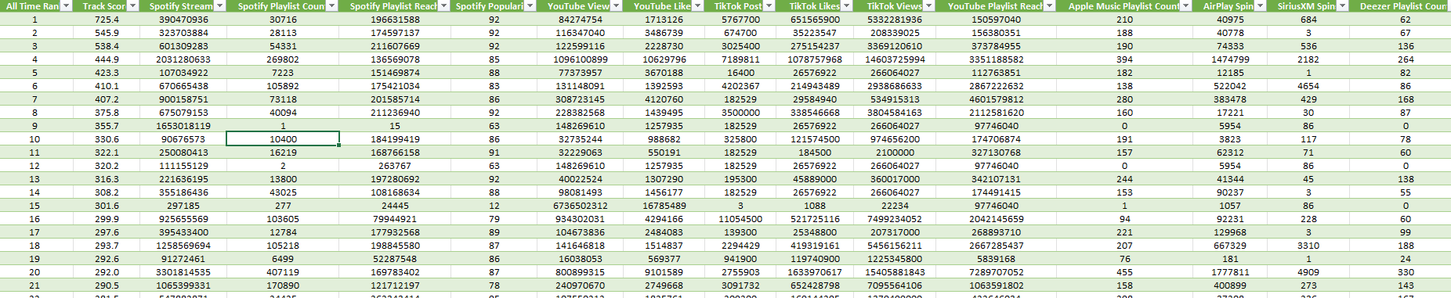
• Standardized artist, album, and track names.
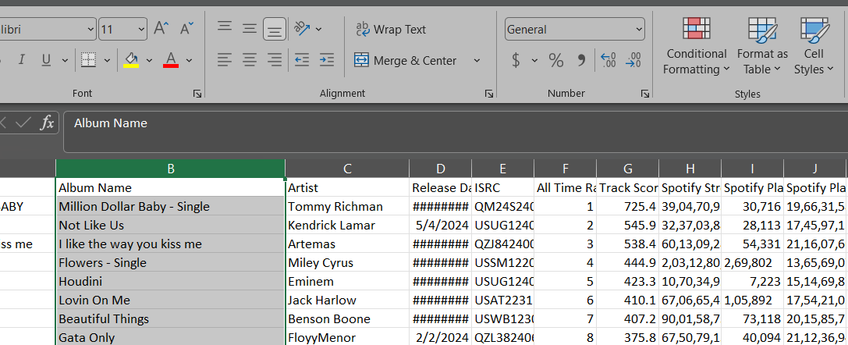
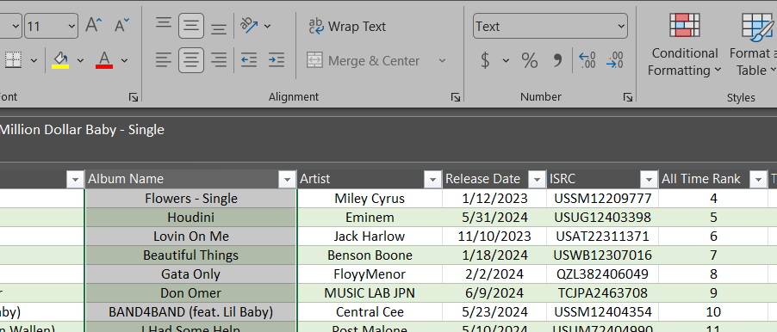
• Corrected metadata using ISRC where available.
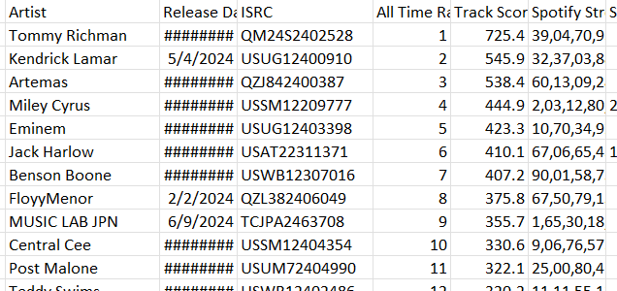

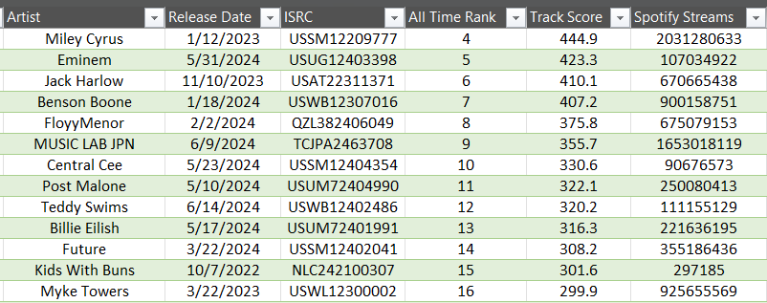
• Standardized date formats.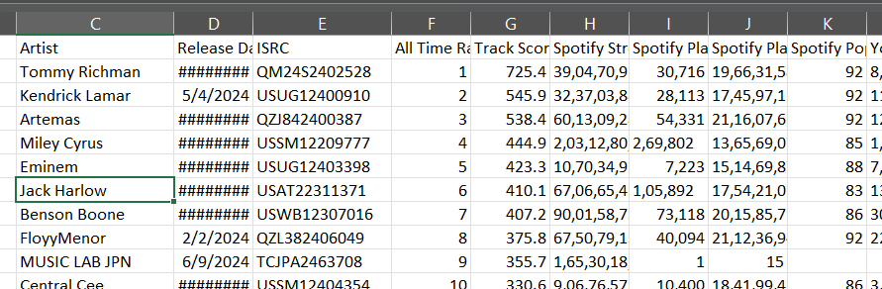
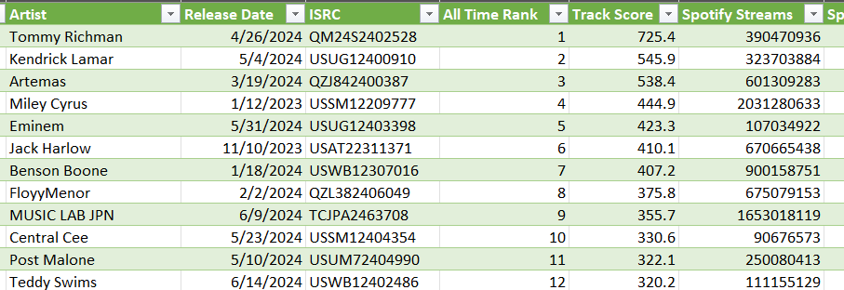
• Fixed inconsistent text formatting and encoding issues.
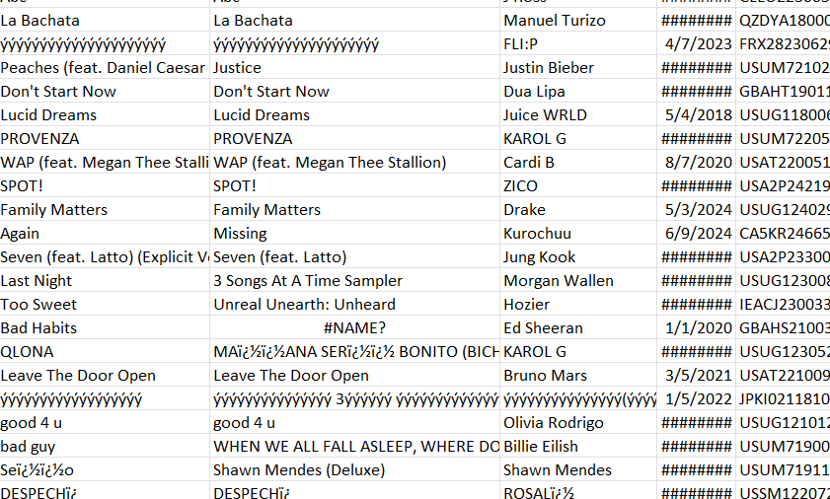
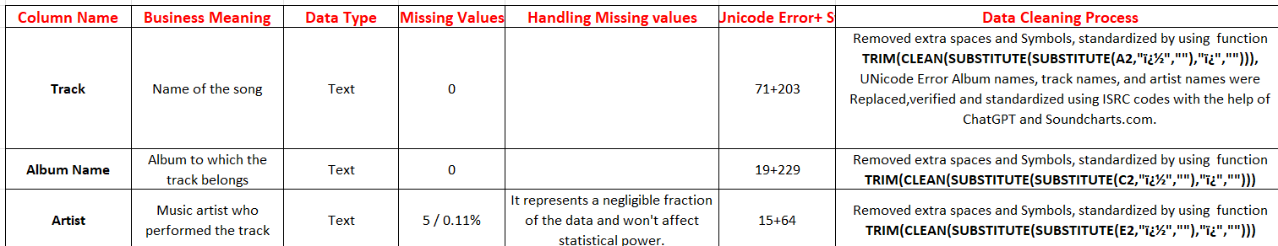
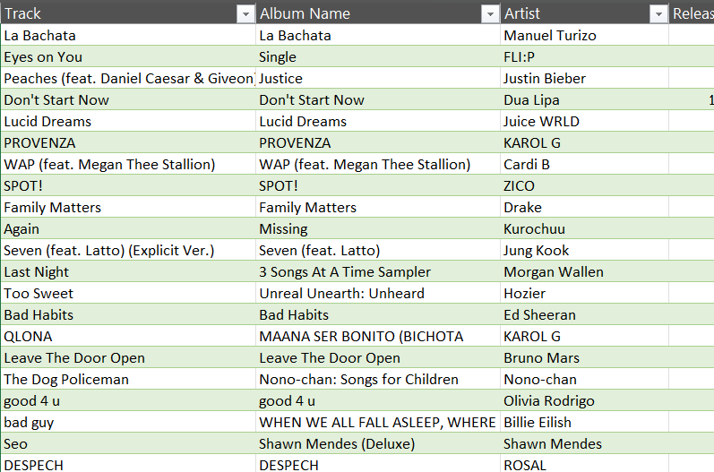
• Verified data quality and prepared the dataset for analysis.
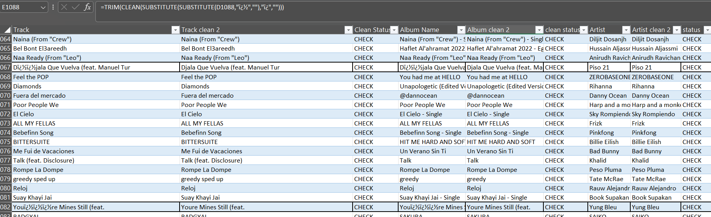

7. Tools & Technologies
• Microsoft Excel
• Power Query
• Power BI
• DAX
• ChatGPT
• Soundcharts (metadata verification)

8. Exploratory Data Analysis (EDA)
EDA included:
• Distribution of artists and songs
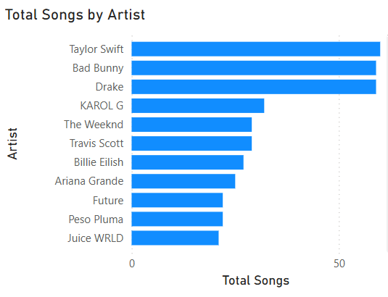
• Release year analysis
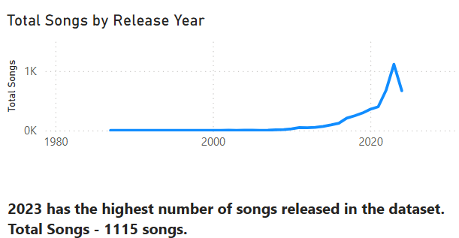
• Platform statistics
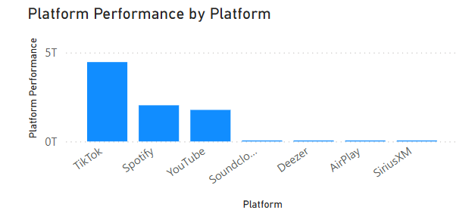
• Popularity distribution
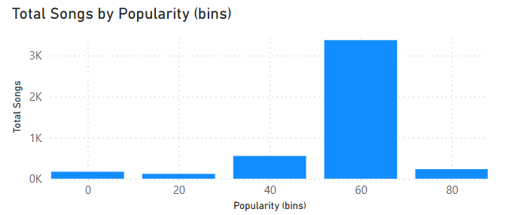
• Missing value and duplicate analysis
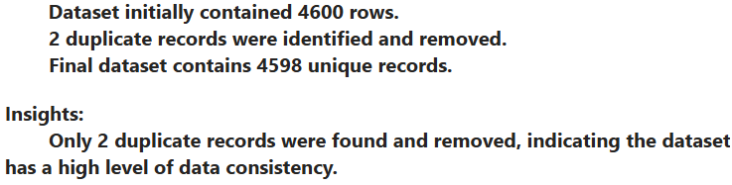
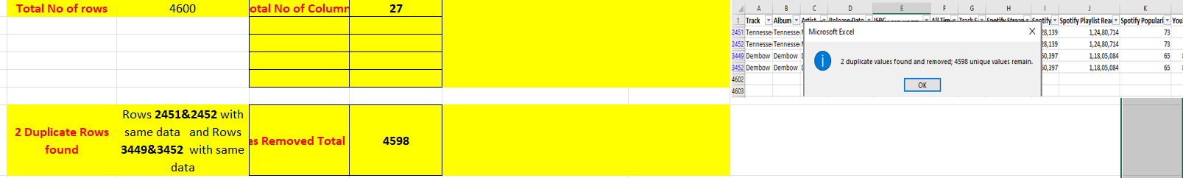
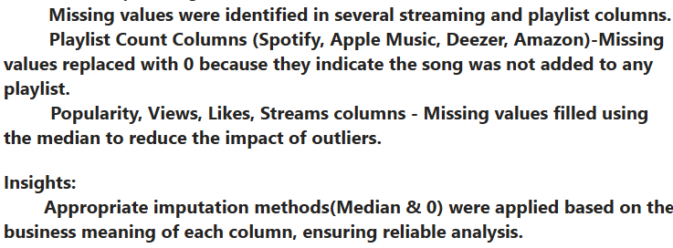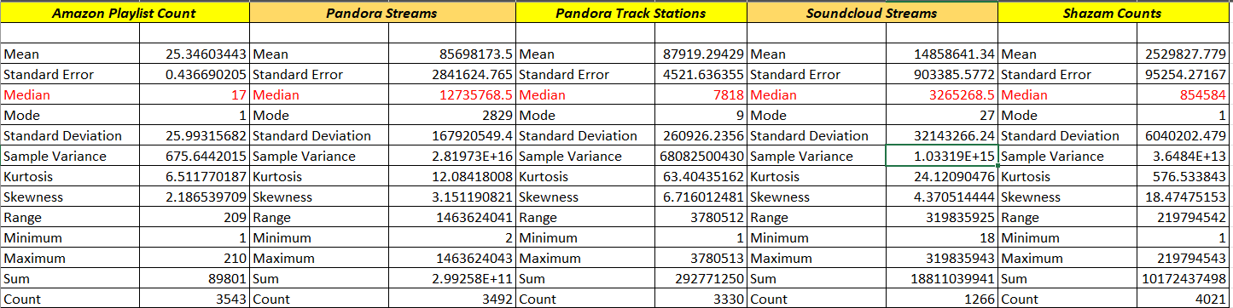
• Metadata validation
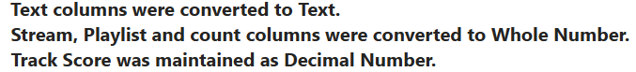
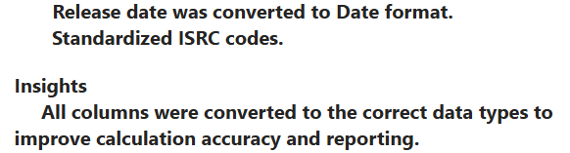
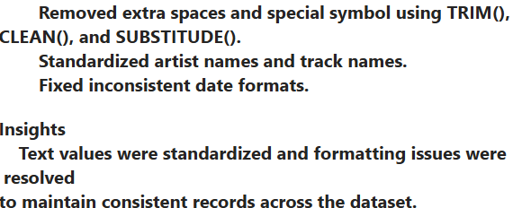
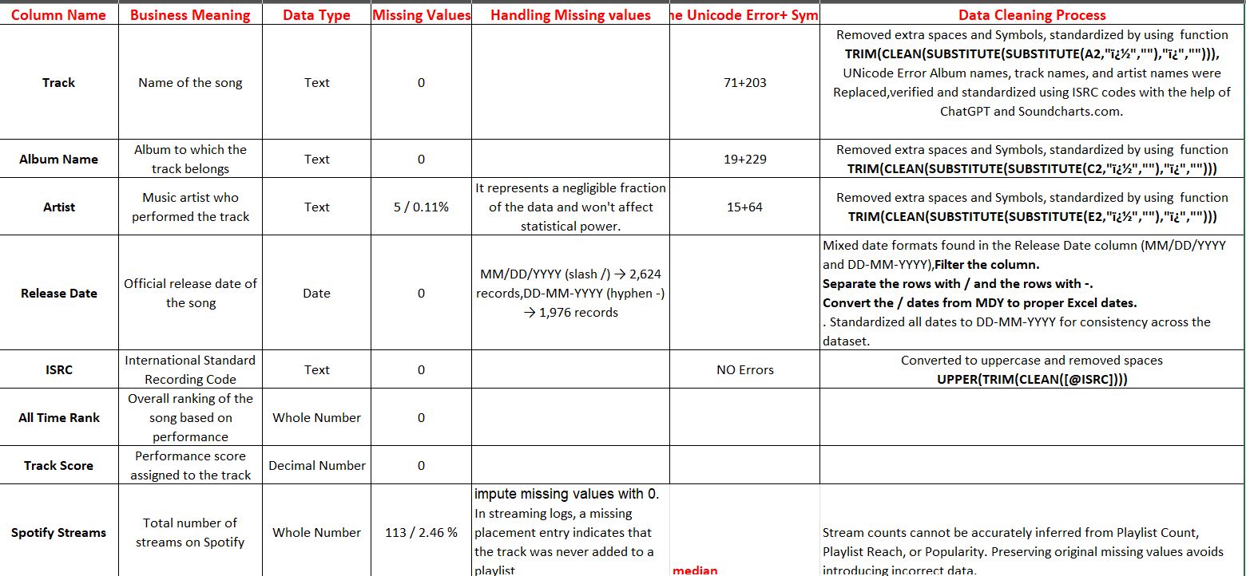
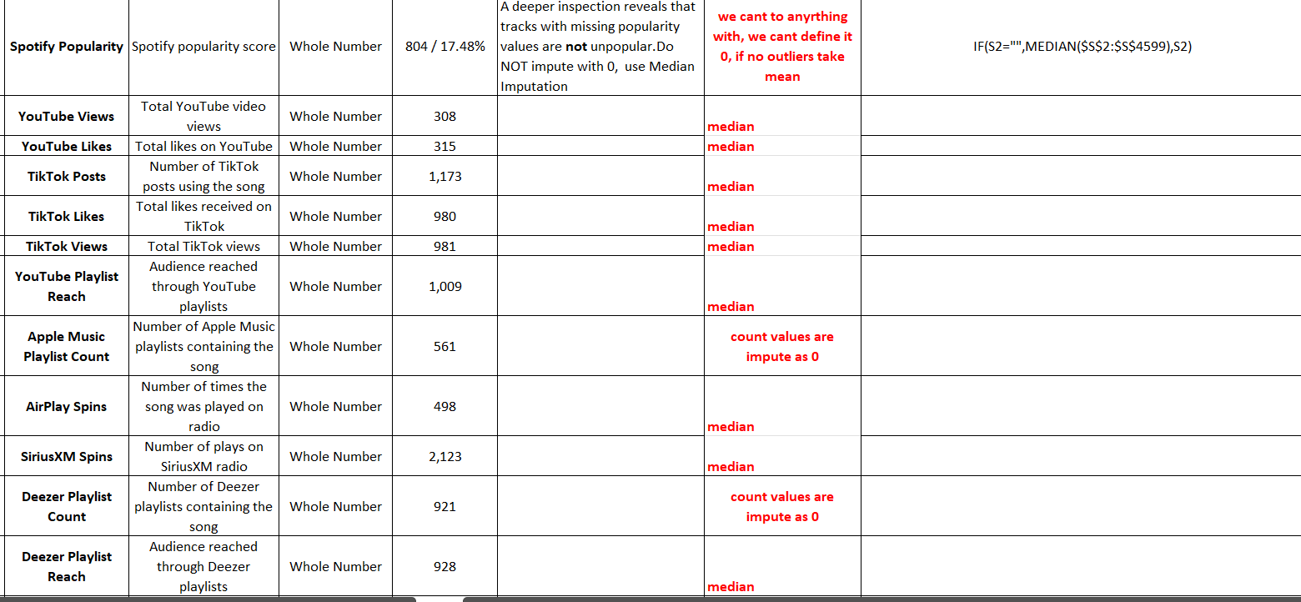
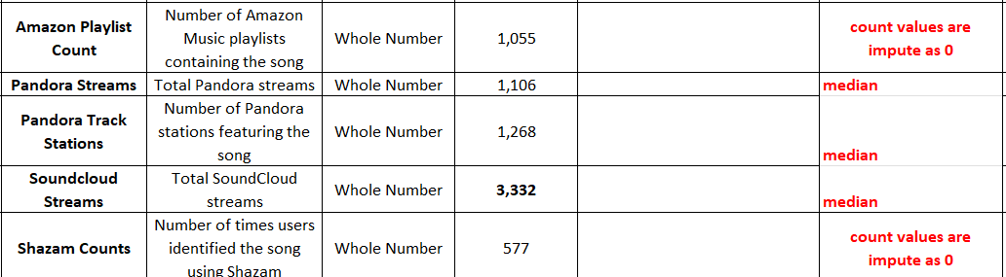

9. Artist Performance Analysis
Analyzed:
• Top 10 artists by total streams
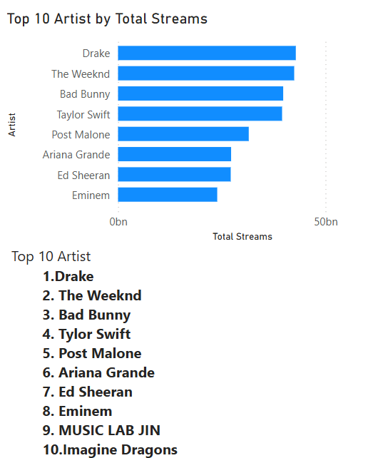
• Highest popularity artists
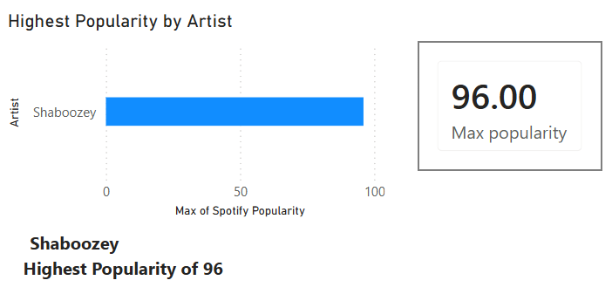
• Most frequently appearing artists

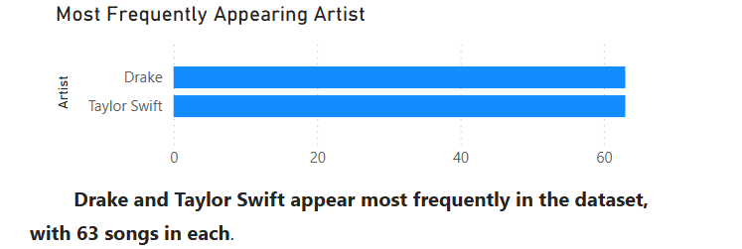
Key insight: A small group of artists contributes a significant share of total streams and audience engagement.

10. Song Performance Analysis
Analyzed:
• Top streamed songs
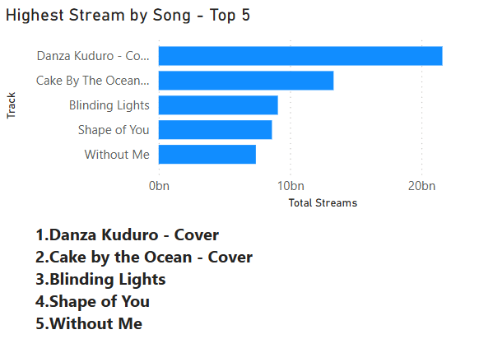
• Most popular songs
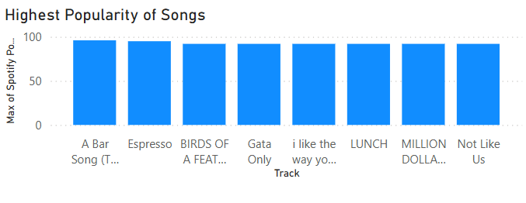
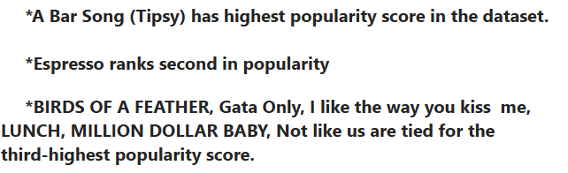
• Albums containing the highest-performing tracks
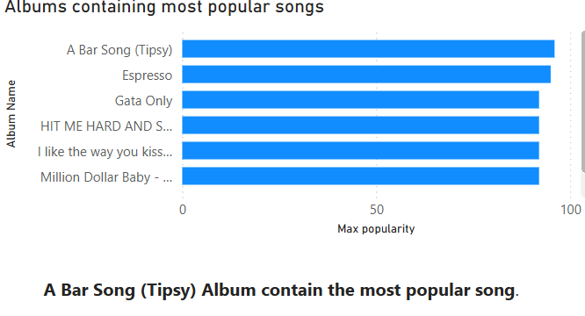
Key insight: Playlist placement strongly influences streaming performance.

11. Platform Analysis
Compared Spotify, YouTube, TikTok, Apple Music, Deezer, Pandora, Amazon Music, SoundCloud, and Shazam.
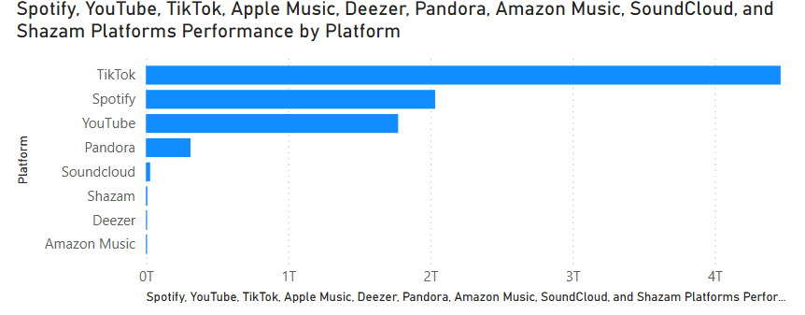
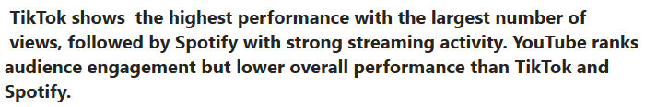
Key findings:
• Spotify is the dominant streaming platform.
• YouTube provides strong audience reach.
• TikTok significantly influences music discovery.

12. Trend Analysis
Analyzed release-year trends, streaming growth, and popularity changes over time.
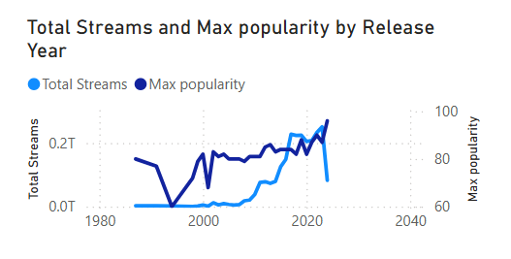
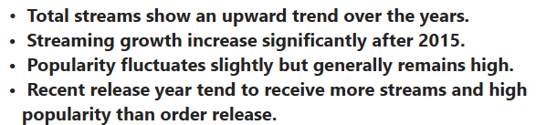
Key finding: Recent releases generally achieve higher engagement through digital promotion.

13. Relationship Analysis
Studied:
• Spotify Streams vs YouTube Views
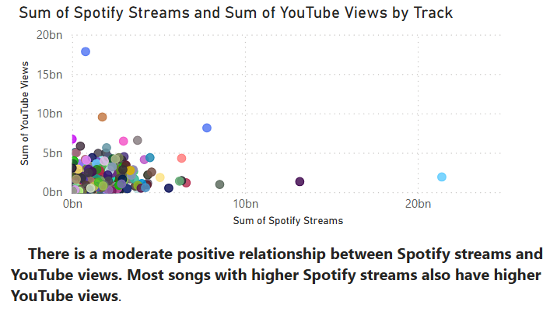
• Spotify Popularity vs Playlist Count
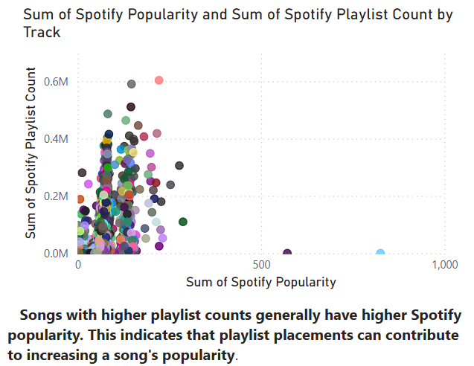
• TikTok Views vs Spotify Streams
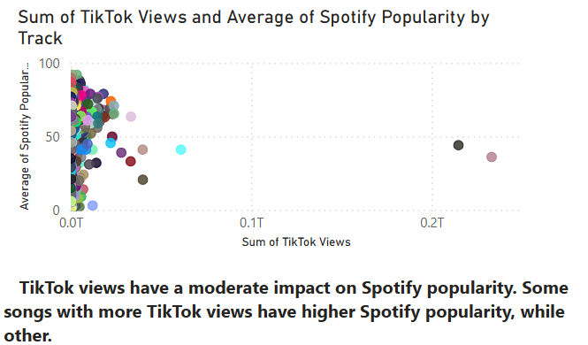
• Playlist Reach vs Popularity
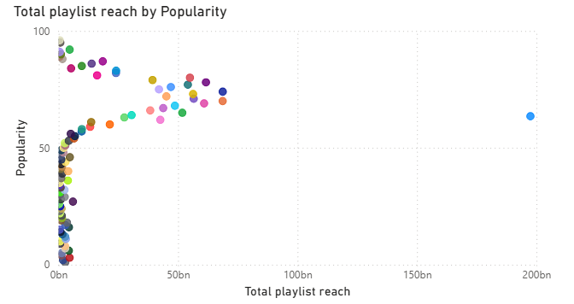
• Shazam Counts vs Streaming Performance
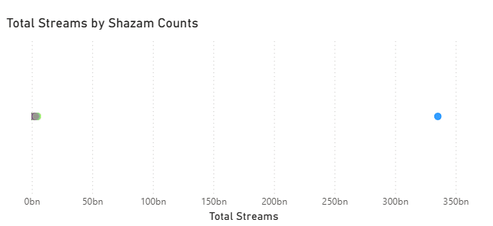
Strong positive relationships were observed between playlist exposure and streaming success.

14. Dashboard Development
Dashboard includes:
• KPI Cards
• Top Artists
• Top Songs
• Platform Comparison
• Release Year Trends
• Interactive slicers for Artist, Album, and Year

15. Business Insights
1. Few artists dominate total streams.
2. Spotify contributes the highest streaming volume.
3. TikTok boosts song discovery.
4. Playlist reach strongly affects popularity.
5. New releases generally perform better.

16. Recommendations
• Increase playlist promotion.
• Invest in TikTok marketing.
• Coordinate releases across platforms.
• Focus marketing on high-performing artists.
• Monitor cross-platform performance regularly.

17. Challenges Faced
• Missing values
• Duplicate records
• Inconsistent metadata
• Encoding issues
• ISRC verification
• Multi-platform data integration

18. Conclusion
This project successfully transformed raw music streaming data into actionable business insights using Excel and Power BI. The dashboard supports data-driven decisions for artists, record labels, and streaming platforms.

19. References
• Project dataset
• Microsoft Excel Documentation
• Microsoft Power BI Documentation
• Microsoft Power Query Documentation
• Soundcharts
• Official streaming platform documentation

